AI ASSITANT CODING
ASSIGNMENT-17
M.SHIVAMANI
2303A52344
BATCH-38

Lab 17 – AI for Data Processing: Data Cleaning and Preprocessing Task 1: Student Academic Data Cleaning
AI Prompt Used
Generate a Python script using pandas to create and clean a student dataset. Include handling missing values, duplicates, standardization, and encoding.

Explanation
In this task, a student dataset is created and cleaned using preprocessing techniques. Missing values in marks, attendance, and department are handled using statistical methods such as mean, median, and mode. Duplicate records are removed based on student ID to ensure data integrity. Text fields such as department names are standardized to maintain consistency. Finally, categorical variables like gender and department are encoded into numerical form for analysis.

Code Screenshot

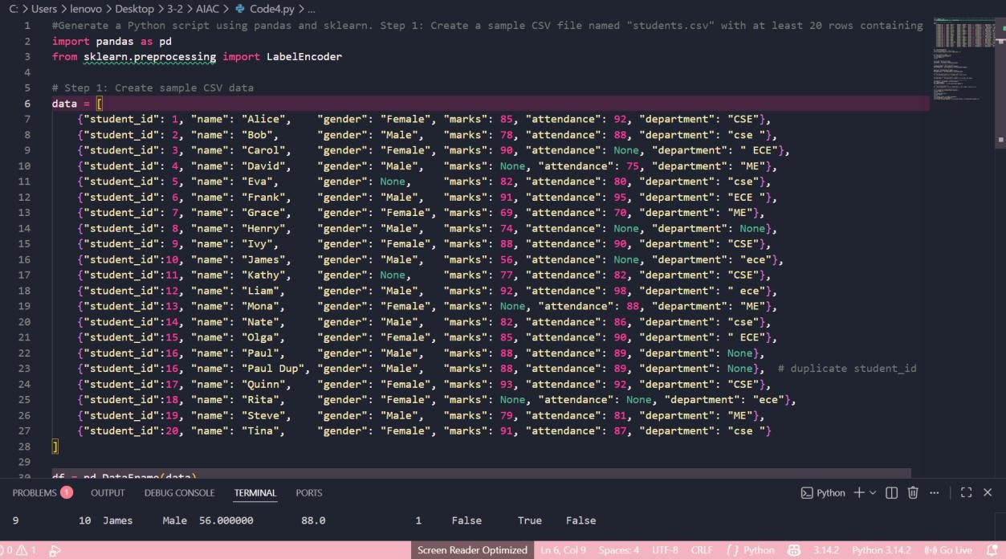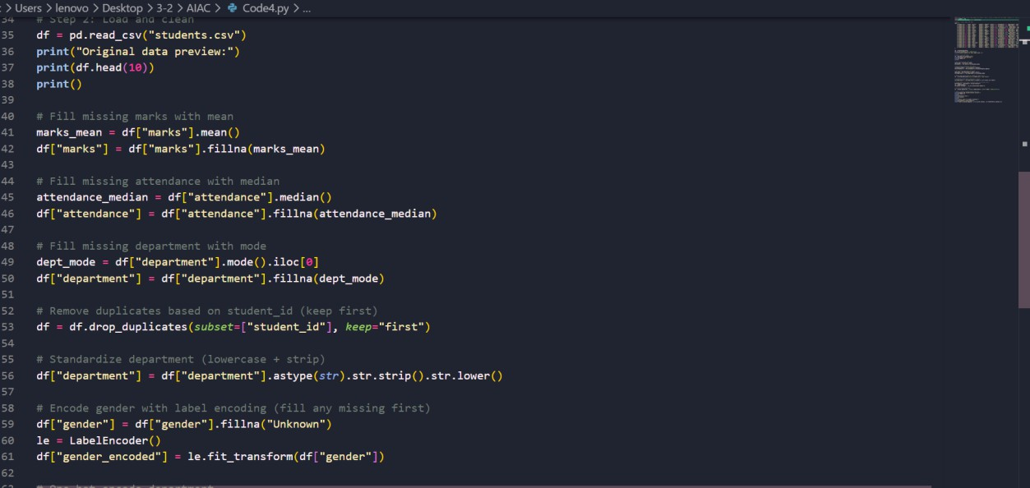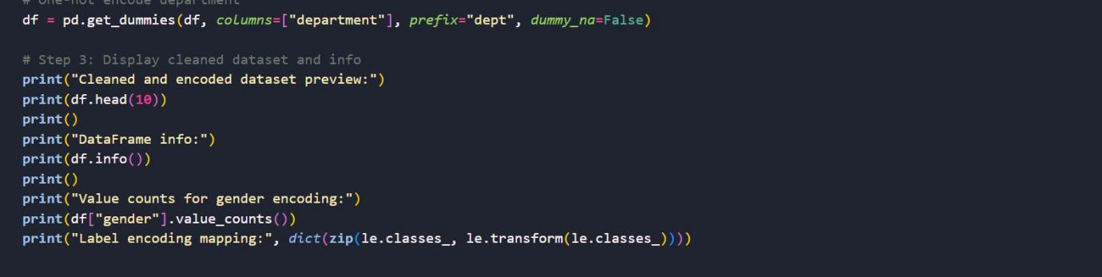

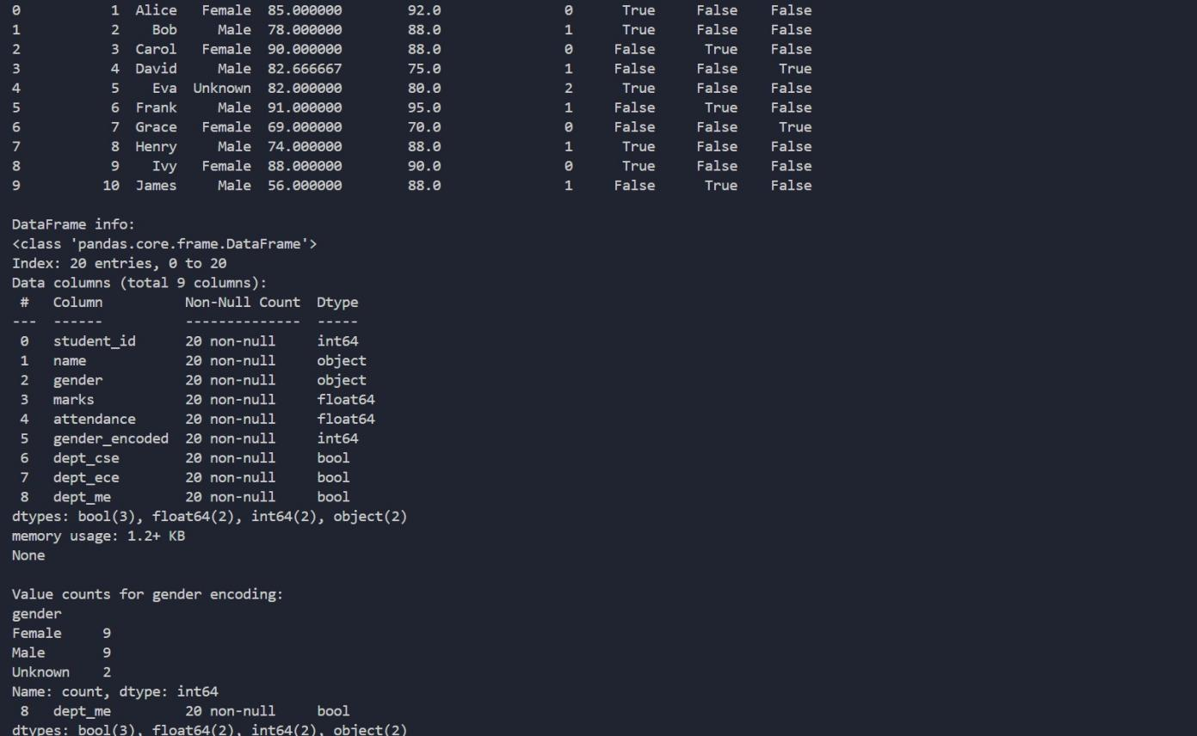

Task 2: Financial Transaction Data Preprocessing AI Prompt Used
Generate Python code to preprocess transaction data including datetime conversion, feature extraction, normalization, and outlier handling.

Explanation
In this task, financial transaction data is preprocessed to make it suitable for analysis. The transaction date is converted into datetime format to enable time-based analysis. Additional features such as transaction month and year are extracted. The transaction amount is
normalized to bring all values into a common scale. Outliers are identified and handled to reduce their impact on analysis.

Code Screenshot

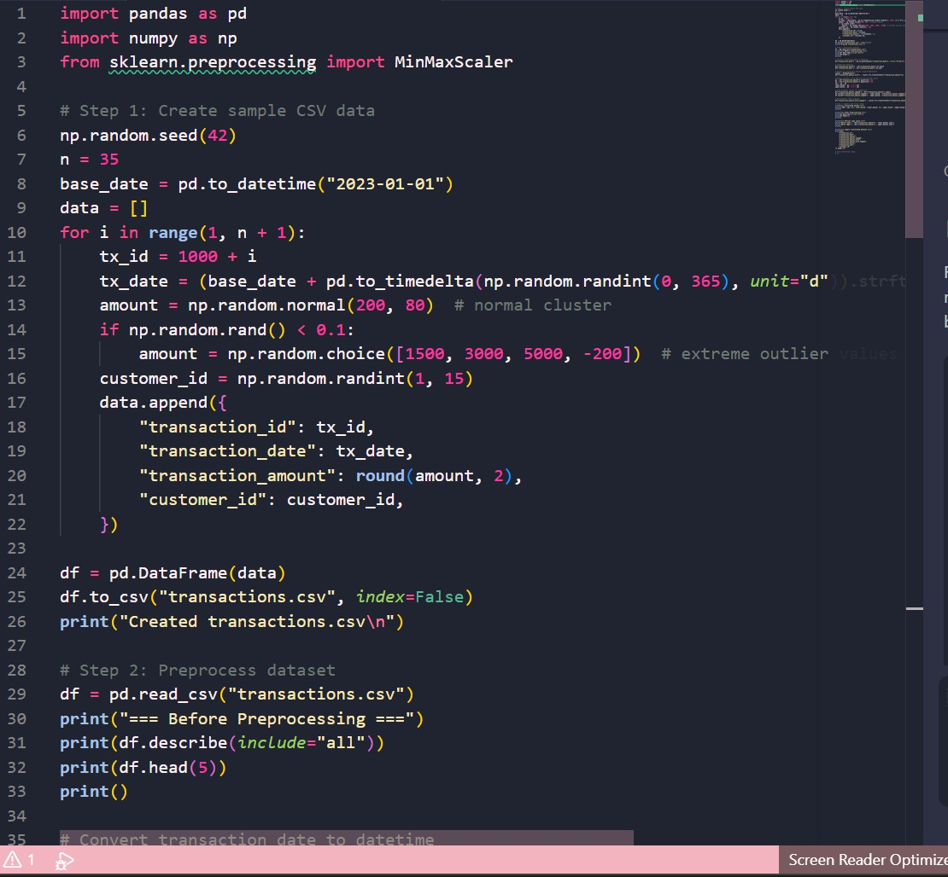

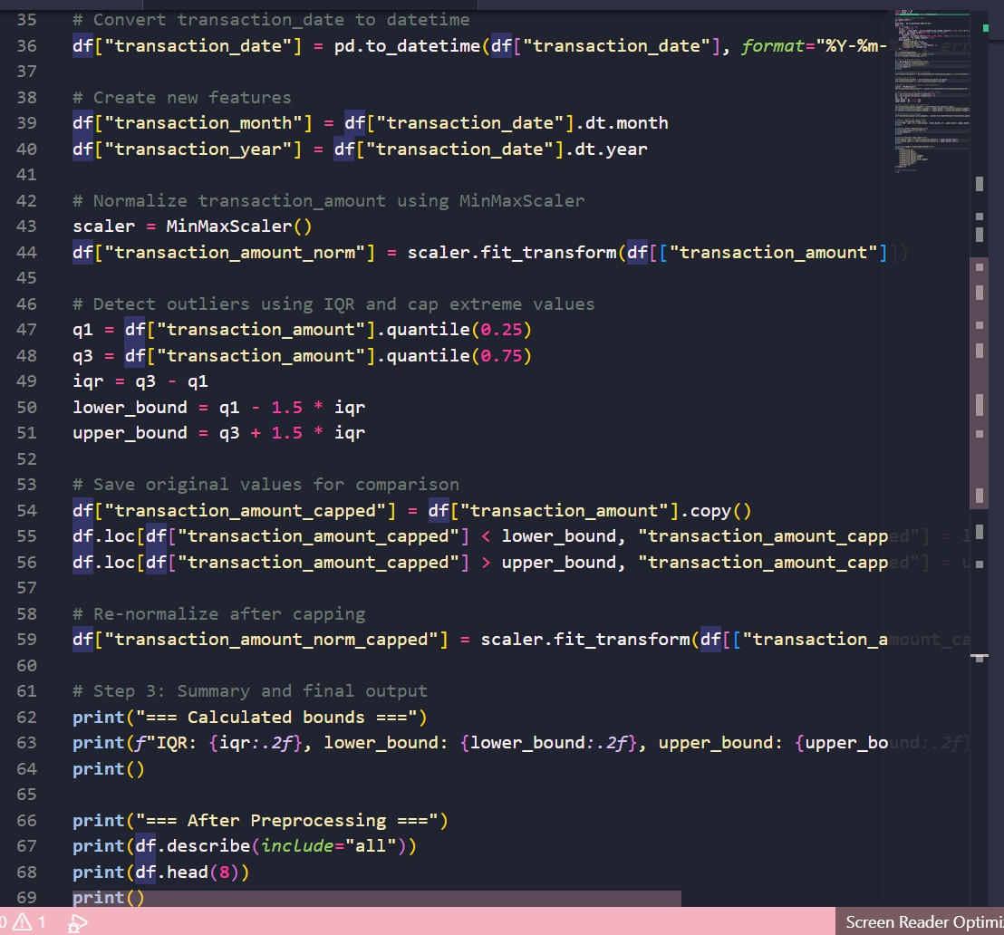

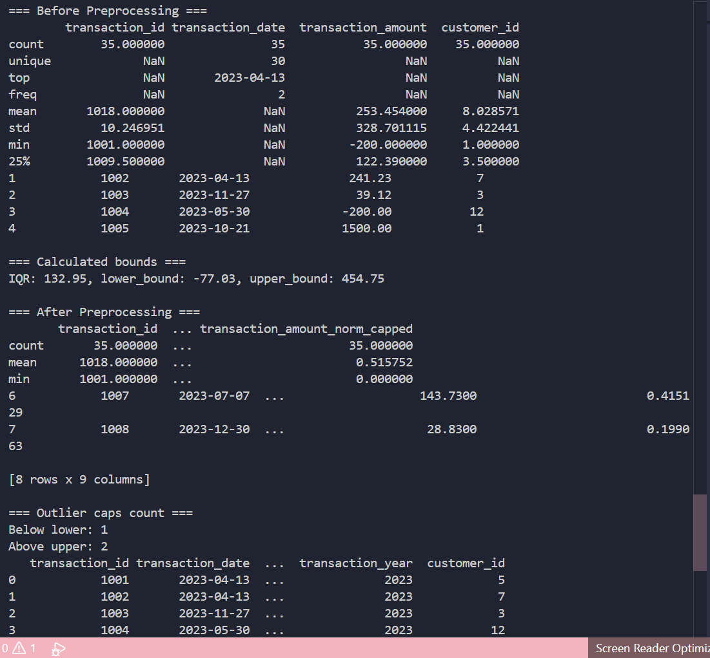

Task 3: Environmental Sensor Data Preparation AI Prompt Used
Generate Python code to clean sensor data by handling missing values, scaling features, encoding categorical data, and splitting dataset.

Explanation
This task focuses on preparing environmental sensor data for machine learning. Missing values in numerical columns like temperature, humidity, and air quality index are replaced using mean values. Numerical features are scaled to improve model performance.
Categorical data such as sensor status is encoded into numerical format. Finally, the dataset is split into training and testing sets for model building.
Code Screenshot

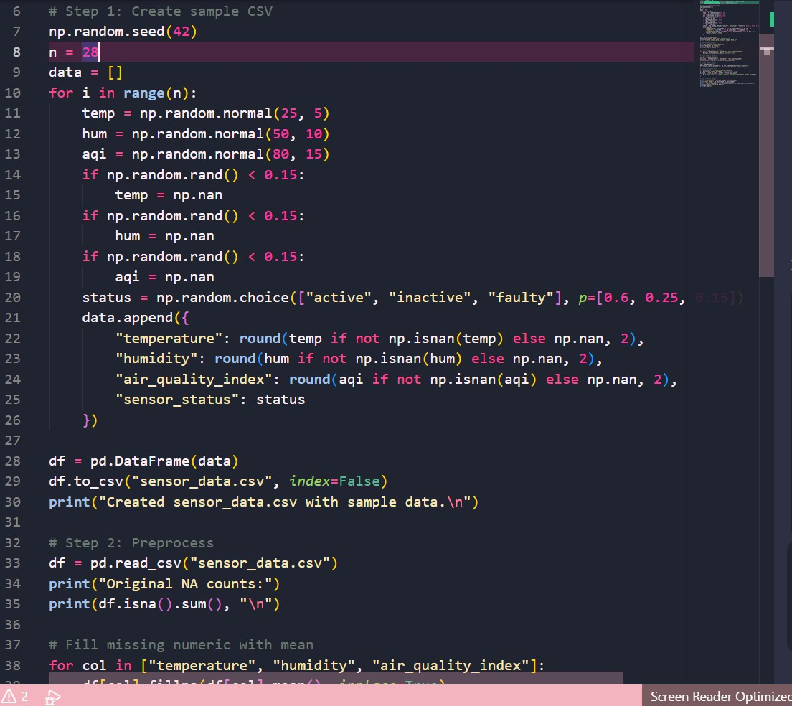

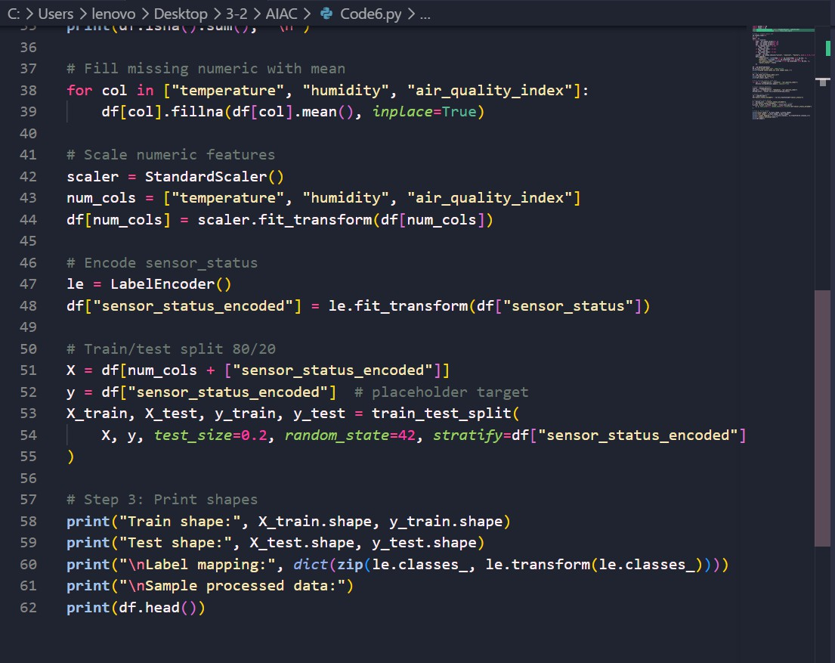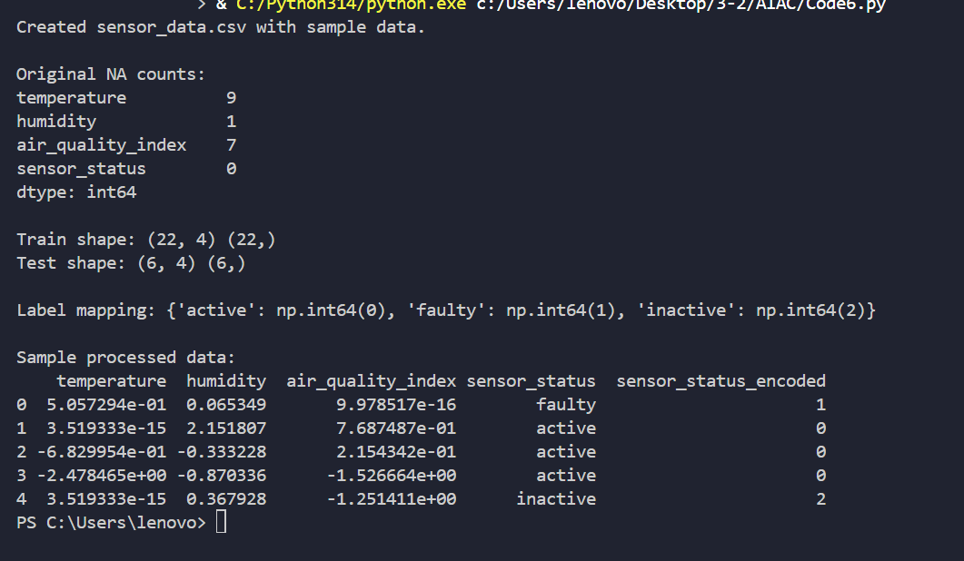

Task 4: Smart City Traffic Data Cleaning

AI Prompt Used
Generate Python script to clean traffic dataset including standardization, missing value handling, duplicate removal, normalization, and comparison.

Explanation
In this task, traffic data collected from multiple sensors is cleaned and standardized. Road and location names are converted into a consistent format by removing extra spaces and converting to lowercase. Missing values in traffic density are filled using median values.
Duplicate records are removed to avoid redundancy. Numerical features such as speed and vehicle count are normalized to ensure uniform scaling across the dataset.

Code Screenshot
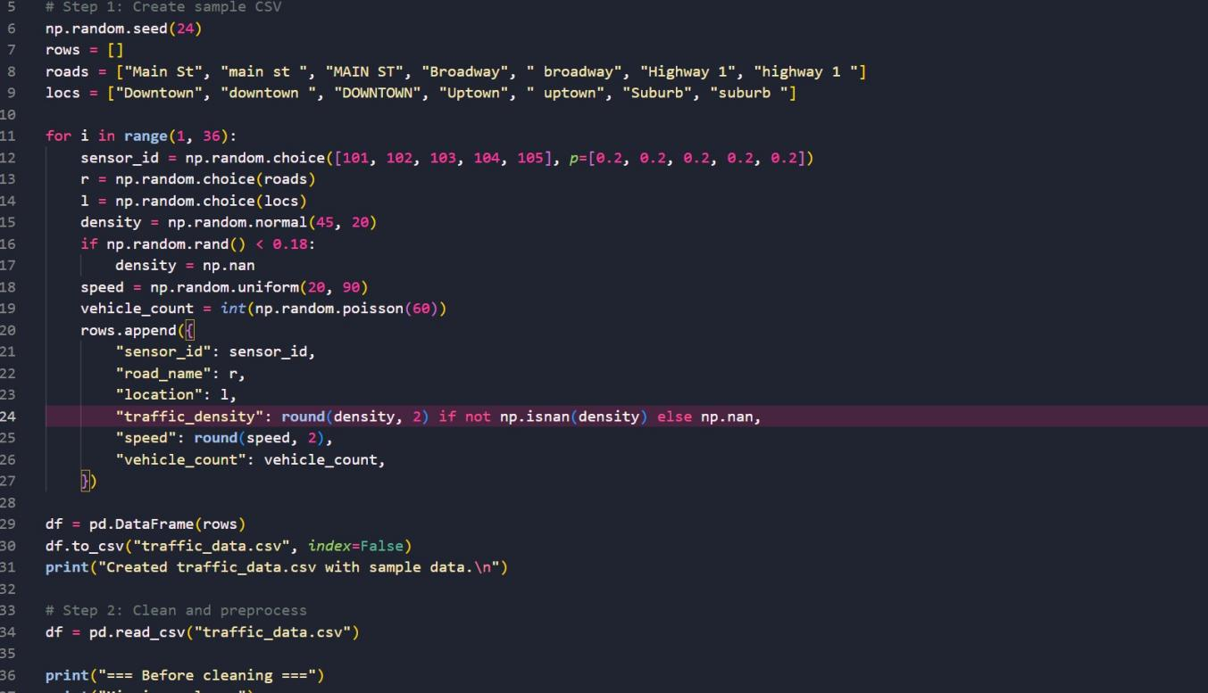

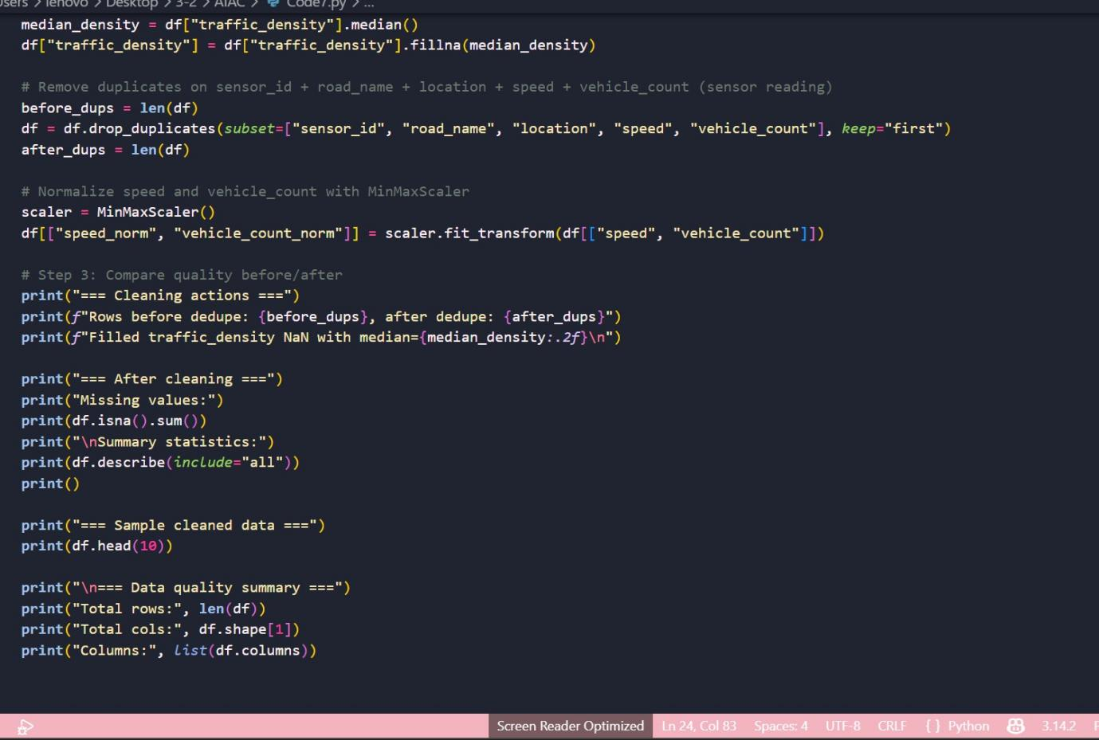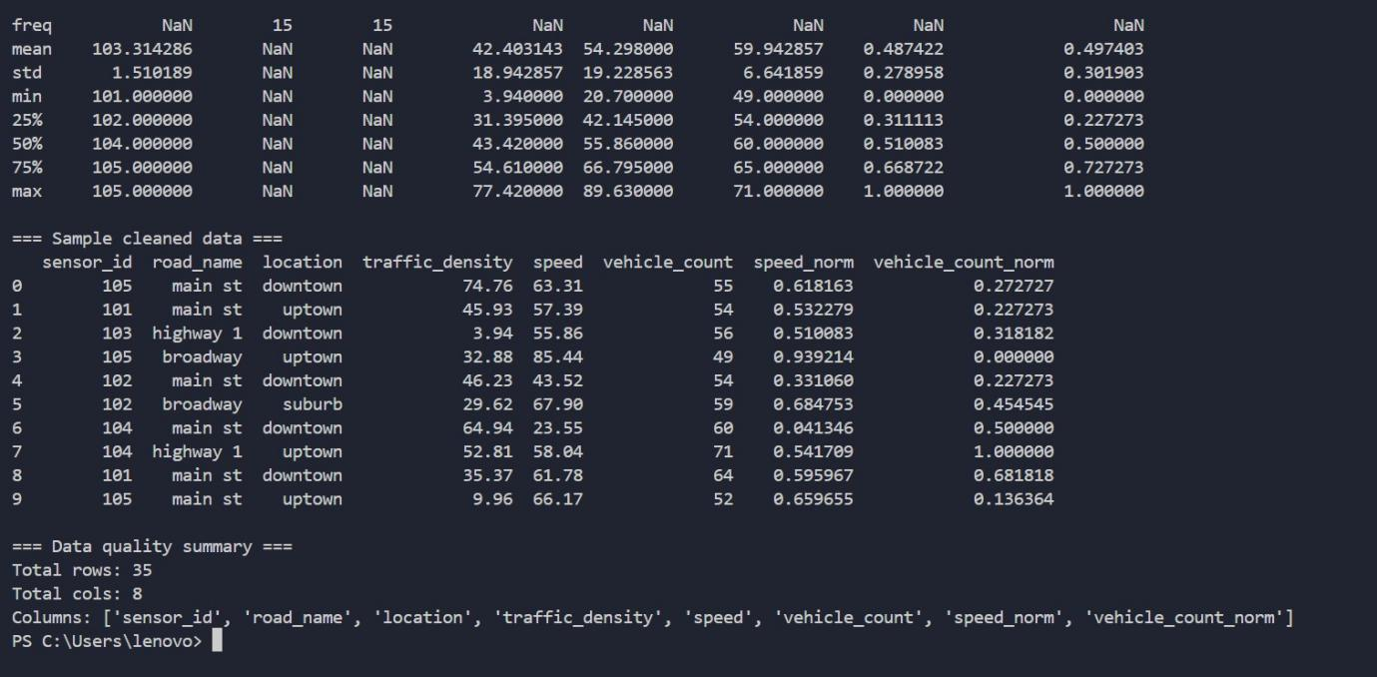

Task 5: Social Media Text Cleaning and Feature Extraction AI Prompt Used
Generate Python code to clean social media text data without using nltk, including regex cleaning, tokenization, stopword removal, and feature extraction.

Explanation

This task involves cleaning and preprocessing textual data from social media. Duplicate and null entries are removed to ensure data quality. Text is cleaned by removing URLs, special characters, and extra spaces using regular expressions. The cleaned text is converted to lowercase and tokenized into words. Stopwords are removed to retain meaningful words. Finally, features such as word count and sentiment score are generated for further analysis.

Code Screenshot
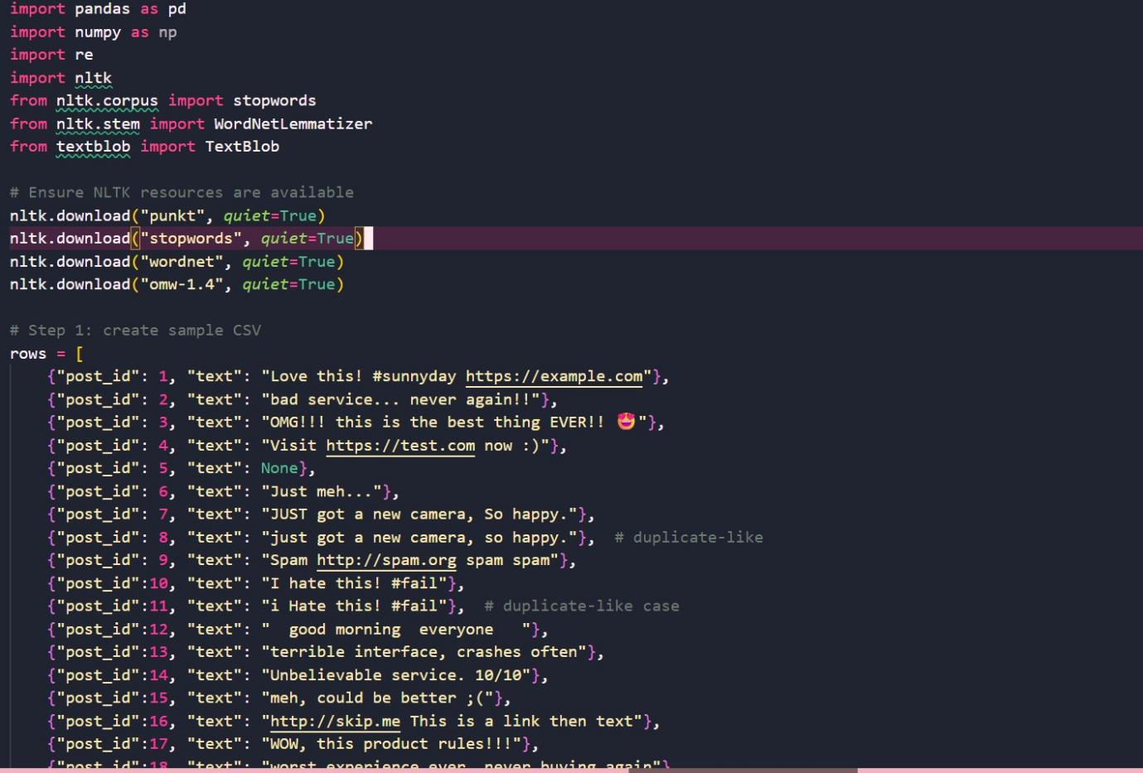
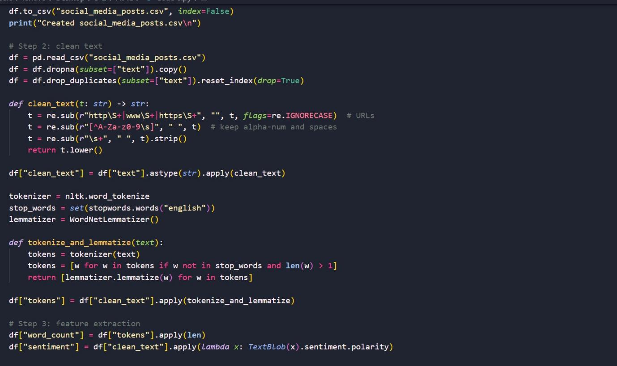

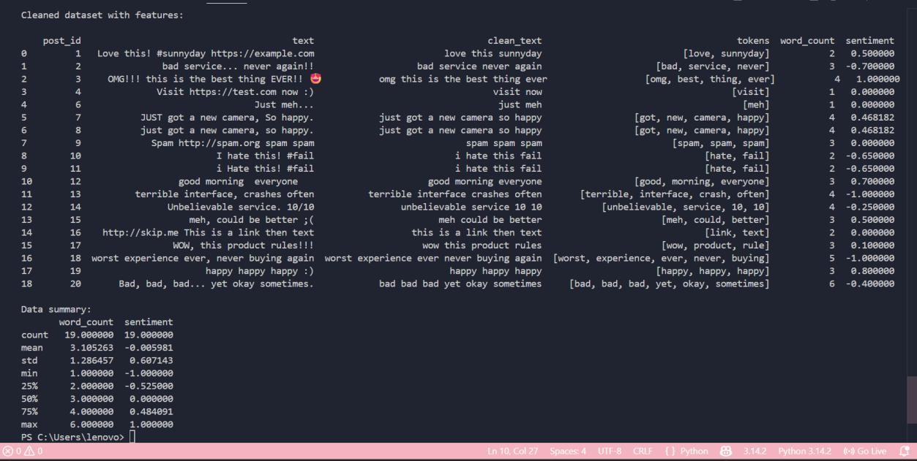

Conclusion
In this lab, various datasets including academic, financial, environmental, traffic, and social media data were cleaned and preprocessed using AI-assisted approaches. Techniques such as handling missing values, removing duplicates, encoding categorical variables,
normalization, and feature extraction were applied effectively. These preprocessing steps significantly improve data quality and ensure better performance of machine learning models. Additionally, the use of AI-generated scripts helps in automating repetitive tasks, saving time, and reducing human errors.

